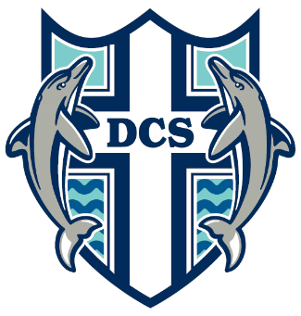
Delta Christian School
Equipping Children for Life

Fall 2015 Annual General Meeting
Monday, November 23, 2015 @ 7:00 pm in the DCS Gym
Agenda
- Welcome & Opening Prayer
- Adoption of the Agenda
- Introduction of the Board of Trustees
- Approval of the Minutes of the Spring General Mtg on May 25, 2015
- Nomination for Board of Trustees & Voting
- Principal’s Report
- DCS Society Membership Policy Update
- Treasurer’s Report – 2014/2015 Fiscal Year End Financials
- Report of the Board Chair & Committees
- Other Business
- Member’s Privilege
- Closing Remarks

